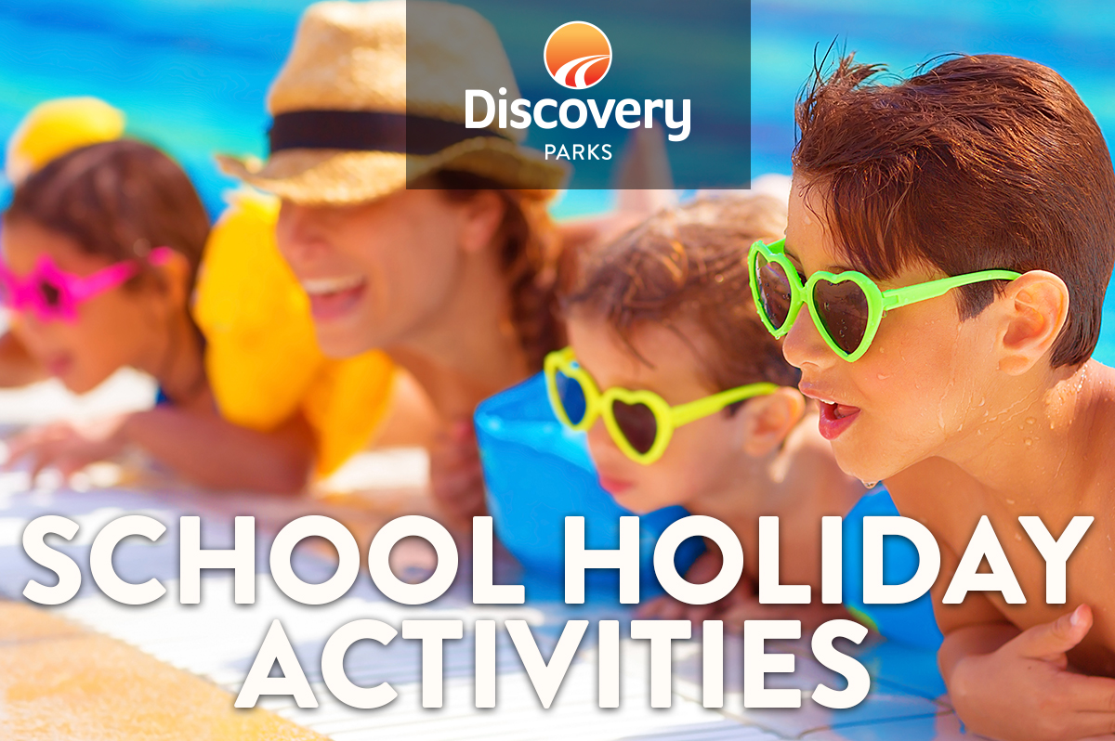
2018/19 SUMMER SCHOOL HOLIDAYS
AT DISCOVERY PARKS – Forster
Lots and lots of great holiday fun for all the family. From face painting, crazy crafts, kids in the kitchen and big screen movie nights to live music and sunset sizzles. Keep an eye on the notice board at the office for daily activities and what’s on at the movies.
DATE | TIME | ACTIVITY | VENUE | COST
14/12/18 | 7pm | Big Screen Movie | Wallamba CK | Free
15/12/18 | 10am | Crazy Hair |  | $2
 | 7pm | Big Screen Movie | Wallamba CK | Free
16/12/18 | 10am | Junk Art | Wallamba CK | $2
 | 7pm | Big Screen Movie | Wallamba CK | Free
17/12/18 | 10am | Kids in the Kitchen | Wallamba CK | $2
 | 7pm | Big Screen Movie | Wallamba CK | Free
18/12/18 | 10am | Crazy Fun Outdoors | Wallamba CK | $2
 | 6pm | Sunset Sizzle – Live Music | Boat Ramp BBQ | Donation
 | 7pm | Big Screen Movie | Wallamba CK | Free
19/12/18 | 10am | Face Painting | Wallamba CK | $2
 | 7pm | Big Screen Movie | Wallamba CK | Free
20/12/18 | 10am | Junk Art | Wallamba CK | $2
 | 7pm | Big Screen Movie | Wallamba CK | Free
21/12/18 | 10am | Kids in the Kitchen | Wallamba CK | $2
 | 7pm | Big Screen Movie | Wallamba CK | Free
22/12/18 | 10am | Crazy Fun Outdoors | Wallamba CK | $2
 | 7pm | Big Screen Movie | Wallamba CK | Free
23/12/18 | 10am | Crazy Hair |  | $2
 | 7pm | Big Screen Movie | Wallamba CK | Free
24/12/18 |  | Junk Art
 | 7pm | Big Screen Movie | Wallamba CK | Free
25/12/18 |  | Christmas Day
 | 7pm | Big Screen Movie | Wallamba CK | Free
26/12/18 | 10am | Kids in the Kitchen | Wallamba CK | $2
 | 7pm | Big Screen Movie | Wallamba CK | Free
27/12/18 | 10am | Crazy Fun Outdoors | Wallamba CK | $2
 | 7pm | Big Screen Movie | Wallamba CK | Free
28/12/18 | 10am | Face Painting | Wallamba CK | $2
 | 7pm | Big Screen Movie | Wallamba CK | Free
29/12/18 | 10am | Junk Art | Wallamba CK | $2
 | 7pm | Big Screen Movie | Wallamba CK | Free
30/12/18 | 10am | Kids in the Kitchen | Wallamba CK | $2
 | 7pm | Big Screen Movie | Wallamba CK | Free
31/12/18 |  | New Year’s Eve
 | 10am | Crazy Outdoor Fun | Wallamba CK | $2
 | 7pm | Big Screen Movie | Wallamba CK | Free
 |  | New Year’s Day
1/1/19 | 10am | Crazy Hair
 |  | Sunset Sizzle – Live Music
 | 7pm | Big Screen Movie | Wallamba CK | Free
2/1/19 | 10am | Junk Art | Wallamba CK | $2
 | 7pm | Big Screen Movie | Wallamba CK | Free
3/1/19 | 10am | Kids in the Kitchen | Wallamba CK | $2
 | 7pm | Big Screen Movie | Wallamba CK | Free
4/1/19 | 10am | Crazy Outdoor Fun | Wallamba CK | $2
 | 7pm | Big Screen Movie | Wallamba CK | Free
5/1/19 | 10am | Face Painting | Wallamba CK | $2
 | 7pm | Big Screen Movie | Wallamba CK | Free
6/1/19 | 10am | Junk Art | Wallamba CK | $2
 | 7pm | Big Screen Movie | Wallamba CK | Free
7/1/19 | 10am | Kids in the Kitchen | Wallamba CK | $2
 | 7pm | Big Screen Movie | Wallamba CK | Free
8/1/19 | 10am | Crazy Outdoor Fun | Wallamba CK | $2
 | 6pm | Sunset Sizzle – Live Music | Boat Ramp BBQ | Donation
 | 7pm | Big Screen Movie | Wallamba CK | Free
9/1/19 | 10am | Crazy hair | Wallamba CK | $2
 | 7pm | Big Screen movie | Wallamba CK | Free
10/1/19 | 10am | Junk Art | Wallamba CK | $2
 | 7pm | Big Screen Movie | Wallamba CK | Free
11/1/19 | 10am | Kids in the Kitchen | Wallamba CK | $2
 | 7pm | Big Screen Movie | Wallamba CK | Free
12/1/19 | 10am | Crazy Outdoor Fun | Wallamba CK | $2
 | 7pm | Big Screen Movie –Finding Dory | Wallamba CK | Free
13/1/19 | 10am | Funny Faces Face Painting | Wallamba CK | $2
 | 7pm | Big Screen Movie | Wallamba CK | Free
14/1/19 | 10am | Junk Art | Wallamba CK | $2
 | 7pm | Big Screen Movie | Wallamba CK | Free
15/1/19 | 10am | Kids in the Kitchen | Wallamba CK | $2
 | 6pm | Sunset Sizzle – Live Music | Boat Ramp BBQ | Donation
 | 7pm | Big Screen Movie | Wallamba CK | Free
16/1/19 | 10am | Crazy Outdoor Fun | Wallamba CK | $2
 | 7pm | Big Screen Movie | Wallamba CK | Free
17/1/19 | 10am | Crazy Hair | Wallamba CK | $2
 | 7pm | Big Screen Movie | Wallamba CK | Free
18/1/19 | 10am | Junk Art | Wallamba CK | $2
 | 7pm | Big Screen Movie | Wallamba CK | Free
19/1/19 | 10am | Kids in the Kitchen | Wallamba CK | $2
 | 7pm | Big Screen Movie | Wallamba CK | Free
20/1/19 | 10.00am | Crazy Outdoor Fun | Wallamba CK | $2
 | 7pm | Big Screen Movie | Wallamba CK | Free
21/1/19 | 10am | Funny Faces Face Painting | Wallamba CK | $2
 | 7pm | Big Screen Movie | Wallamba CK | Free
22/1/19 | 10am | Junk Art | Wallamba CK | $2
 | 7pm | Big Screen Movie | Wallamba CK | Free
23/1/19 | 10am | Kids in the Kitchen | Wallamba CK | $2
 | 7pm | Big Screen Movie | Wallamba CK | Free
24/1/19 | 10am | Crazy Outdoor Fun | Wallamba CK | $2
 | 7pm | Big Screen Movie | Wallamba CK | Free
25/1/19 | 10am | Crazy Hair | Wallamba CK | $2
 | 7pm | Big Screen Movie | Wallamba CK | Free
26/1/19 |  | Australia Day Fun – Live Music
 | 7pm | Big Screen Movie | Wallamba CK | Free
27/1/19 | 10am | Junk Art | Wallamba CK | $2
 | 7pm | Big Screen Movie | Wallamba CK | Free

